**Dental Care Record:**

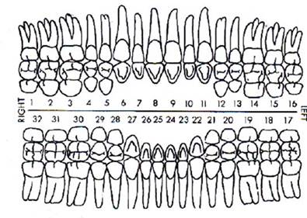Name: Offender #: D.O.B.:

|  |  |  |
| --- | --- | --- |
| **Date:** | **Time:** | **Comments:** |
|  |  |  |
|  |  |  |
|  |  |  |
|  |  |  |
|  |  |  |
|  |  |  |
|  |  |  |
|  |  |  |
|  |  |  |